**BIOTIC STRESSES**

Doped CQDs alleviates detrimental effects of biotic stresses through improving nutrients uptake, hormone levels and enhancing the antioxidant defense system against pathogen attack. Phytopathogen infection is a typical biotic stress that annually causes a significant decrease in crop productivity (Li et al. 2020). For instance, CDs enhance the rice plant disease resistance ability through inducing the over expression of related genes such as thionin (Os06g32600) (Li et al. 2018). Additionally, the CQDs were also degraded into CO2 and plant hormone analogues, which then promoted the rice plant growth, while the CO2 was converted into carbohydrates through the Calvin cycle of photosynthesis (Lahiani et al. 2016).

Luo et al. (2021) reported that N-CDs (nitrogen doped carbon dots) suppressed bacterial wilt in tomatoes, statistically reduced disease severity by 71.19%. Studied showed, N-CDs were 1.56 times more effective at preventing disease than pure CDs (P-CDs). This indicates that N-CDs stimulated the anti-oxidative enzyme activity in plants, and then reduced the pathogen induced oxidative stress. Song et al. (2018) reported that the CDs extracted from cigarette smoke have antimicrobial activities, suggesting that the CDs can function as an effective broad-spectrum antibiotic, even against drug-resistant bacteria. CQDs were tested for inhibitory activity against plants (B. cinerea, A. alternata, and F. oxysporum) using optical density as an estimate for spore growth. CQDs significantly reduced mycelial growth of P. infestans and sporangia development. CQDs enhanced the dsRNA-induced gene silencing in Phytophthora infestans and to evaluate the CQDs cytotoxicity (Kostov et al. 2022). Wang et al. (2014) examined the antifungal activity of CDs against Fusarium graminearum and Fusarium poae, two significant plant pathogenic fungus. Aauthors showed that suppression of water uptake and the stimulation of plasmolysis, are two mechanisms underlying the antifungal actions of these CDs.

N-CQDs not only showed potent anti-pathogen actions but were also used for pesticide residue detection. N-CQDs exceptionally low plant toxicity was confirmed in sorghum seedlings (Wang et al. 2021). The studied demonstrated that carbon quantum dots have considerable potential as green pesticides.

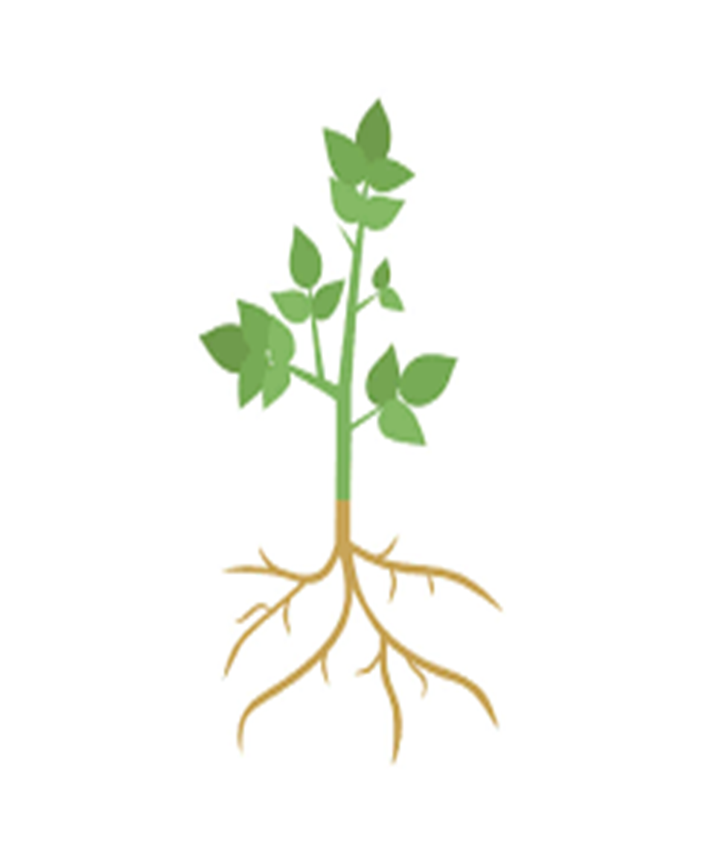

Doped CQDs exposure to plants

Induction of ROS production in plants

Activation of plant defense mechanisms

Expression of defense- related gene and enzymes

Inhibition of pathogen growth and spread

Improved Plant growth and development

Enhanced photosynthesis and nutrient uptake

Enhance the plant’s defense mechanism against biotic stresses

Regulating the gene expression in plants

Inducing the production of secondary metabolites such as phenolic, flavonoids and alkaloids

**bacteria**

**Pest**

**Fungi**

CQDs have antifungal activity against plant pathogenic fungi

Figure1. CQDs used to modulate plant growth and protect plants from stresses.

**References**

1. Li, Y., Xu, X., Wu, Y., Zhuang, J., Zhang, X., Zhang, H. and Liu, Y. (2020). A review on the effects of carbon dots in plant systems. Mater. Chem. Front. 4(2), 437-448.
2. Li, H., Huang, J., Lu, F., Liu, Y., Song, Y., Sun, Y. and Kang, Z. (2018). Impacts of carbon dots on rice plants: boosting the growth and improving the disease resistance. ACS Appl. Bio Mater. 1(3), 663-672.
3. Lahiani, M. H., Dervishi, E., Ivanov, I.; Chen, J. and Khodakovskaya, M. (2016) Comparative Study of Plant Responses toCarbon-Based Nanomaterials with Different Morphologies.Nano-tech. 27(26), 265102−265115.
4. Song, Y., Lu, F., Li, H., Wang, H., Zhang, M., Liu, Y. and Kang, Z. (2018). Degradable carbon dots from cigarette smoking with broad-spectrum antimicrobial activities against drug-resistant bacteria. ACS Appl. Bio Mater. 1(6), 1871-1879.
5. Luo, X., Cao, X., Wang, C., Yue, L., Chen, X., Yang, H. and Xing, B. (2021). Nitrogen-doped carbon dots alleviate the damage from tomato bacterial wilt syndrome: systemic acquired resistance activation and reactive oxygen species scavenging. Environ. Sci. 8(12), 3806-3819.
6. Kostov, K., Andonova-Lilova, B. and Smagghe, G. (2022). Inhibitory activity of carbon quantum dots against Phytophthora infestans and fungal plant pathogens and their effect on dsRNA-induced gene silencing. Biotechnol. Biotechnol. Equip. 36(1), 949-959.
7. Wang, X., Liu, X., Chen, J., Han, H. and Yuan, Z. (2014) Evaluation and mechanism of antifungal effects of carbon nanomaterials in controlling plant fungal pathogen. Carbon. 68, 798−806.
8. Wang, Z., Liu, Q., Leng, J., Liu, H., Zhang, Y., Wang, C. and Lei, H. (2021). The green synthesis of carbon quantum dots and applications for sulcotrione detection and anti-pathogen activities. J. Saudi Chem Soc. 25(12), 101-373.